Navigate to browser and enter below url

<https://www.jenkins.io/download/>

select windows and click on download

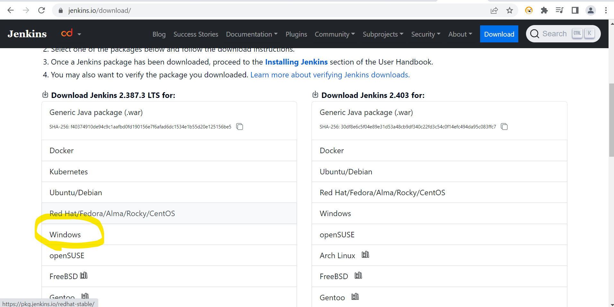

Navigate to downloaded file location and double click on file

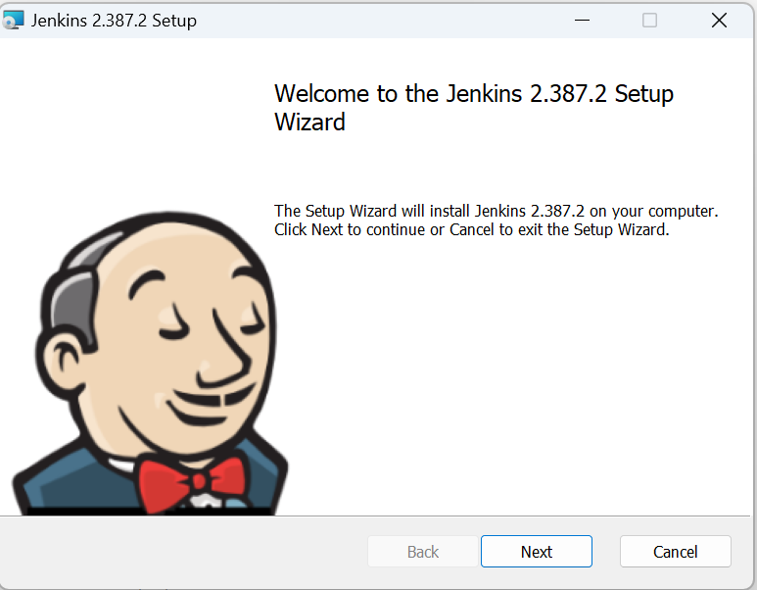

Click on next button

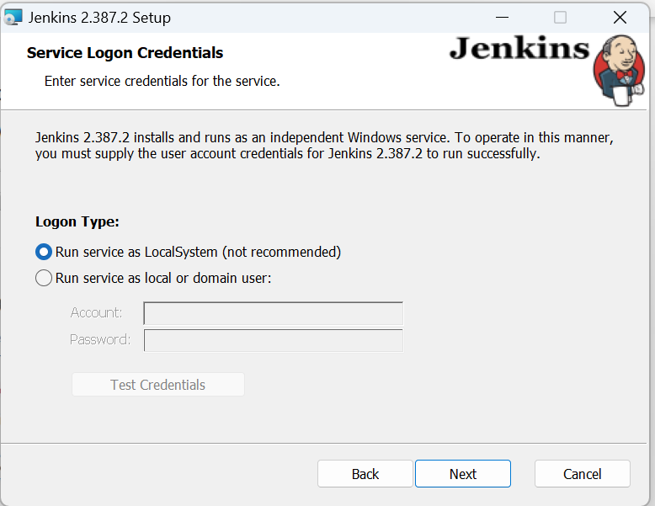



Select the Run service as Local System option and click on next button

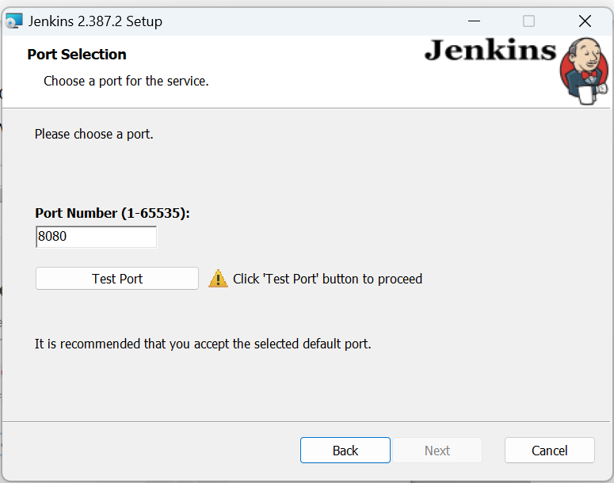

Enter the port number (we can add any number in between 1 to 65535)

Click on Test Port icon

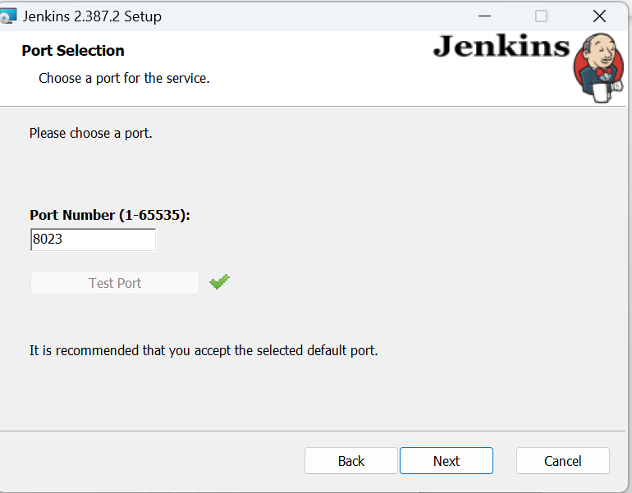

Click on next button

Click on change icon and select the jdk file path

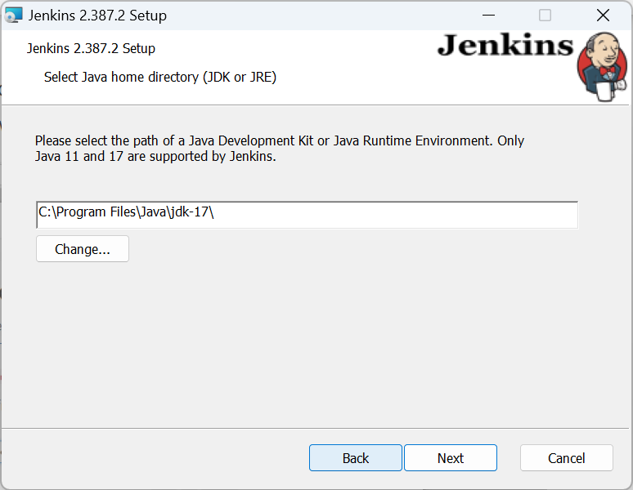

Click on next button

Click on next button

Click on install button

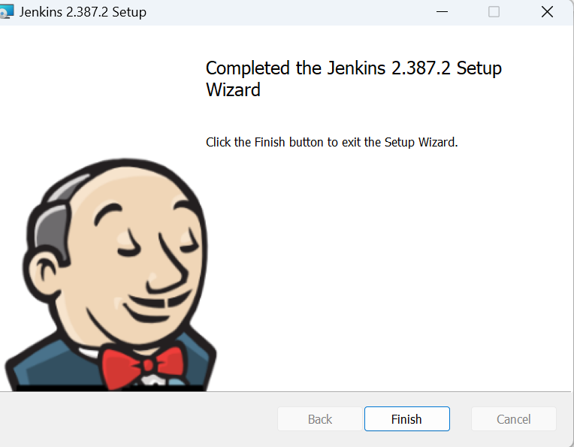

Click on finish button

Paste the above url in file manager ,then you will get the initial admin password